**ПРЕДСТАВЛЕНИЯ – это псевдонимы для запросов SELECT**

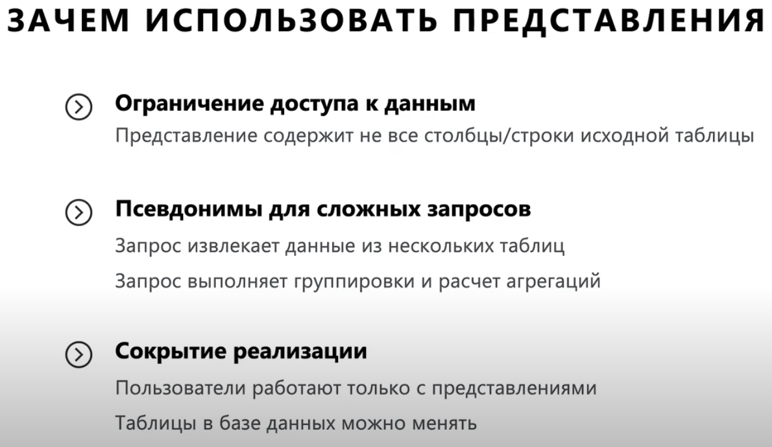

CREATE VIEW nameOfView columnName, columnName2 AS

SELECT columnName, columnName2

FROM tableName

CREATE VIEW prodcuts_v AS

SELECT p.id AS id, p.name AS product_name, t.type_name AS product_type, p.price AS product_price

FROM products AS p JOIN product_types AS t

ON p.type_id = t.id

DROP VIEW nameOfView